December 2021

Dear Hawthorne Families:
As we continue our 2021 school year with unexpected and changing circumstances, please know that the Hawthorne Parent Teacher Association’s priority is and always will be our children, parents and educators. As proof of our unwavering support, we’d like to take this opportunity to update you on our plans for this term. While things may look different than in previous years, we will do everything we can to provide our children and families with fun and safe activities in person if possible, or in a virtual format, but we need your help.
We’d like to invite you to join us in making a difference in the education, health and welfare of our children. We all want to do what is best for children and by working together, parents, teachers, administrators and the community, we can provide much needed support to our school allowing us to continue programs and projects that benefit our children.
We welcome all family members - moms, dads, stepparents, grandparents, teachers, aunts and uncles, to volunteer / participate in PTA events. Their membership helps reflect the rich cultural diversity present at Hawthorne Elementary.
Remember, becoming a member does not obligate you in any way to attend or assist with these functions, BUT, the more members we have, the stronger voice we have to advocate for our children!
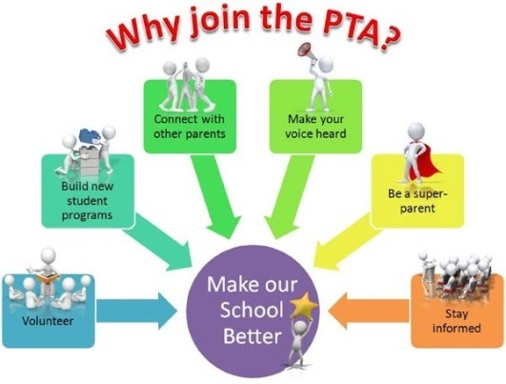

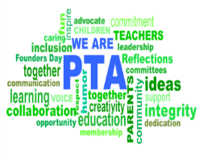
Join the PTA
The cost is $20.00 per household. There is a $4.00 fee that goes to the
NJPTA Council. The remainder will be used to purchase supplies for the school and
students. For memberships visit https://hawthorneschpta.memberhub.store/
Please help us to make a difference for our students, our teachers, and our staff by doing what you can to help.

Sincerely,
Your Hawthorne PTA Executive Board

