3rd Grade Supply List

2019-2020

Please bring the following supplies to school by **September 6th** in order to facilitate instruction. Please ***do not write your child’s name*** on the supplies as they will be shared within the classroom community.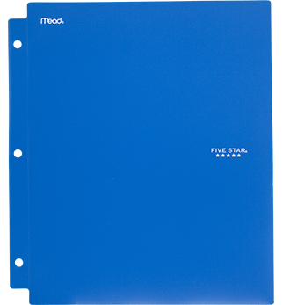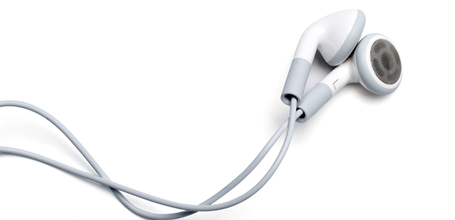

* A Backpack (No Wheels)
* One (1) Pair of Earbuds
* Two (2) **Hard Plastic** Two-Pocket Folders with Holes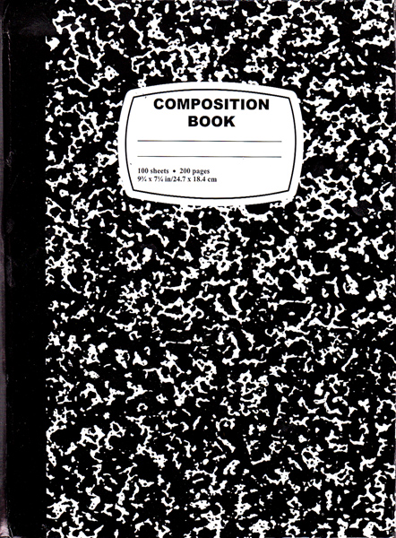
* Eight (8) **Black and White ONLY** Marble Composition Notebooks (Do not label them.)
* Six (6) Boxes of ***Sharpened*** #2 ***Ticonderoga*** Pencils
* One (1) Pack of 24 ***Crayola*** Colored Pencils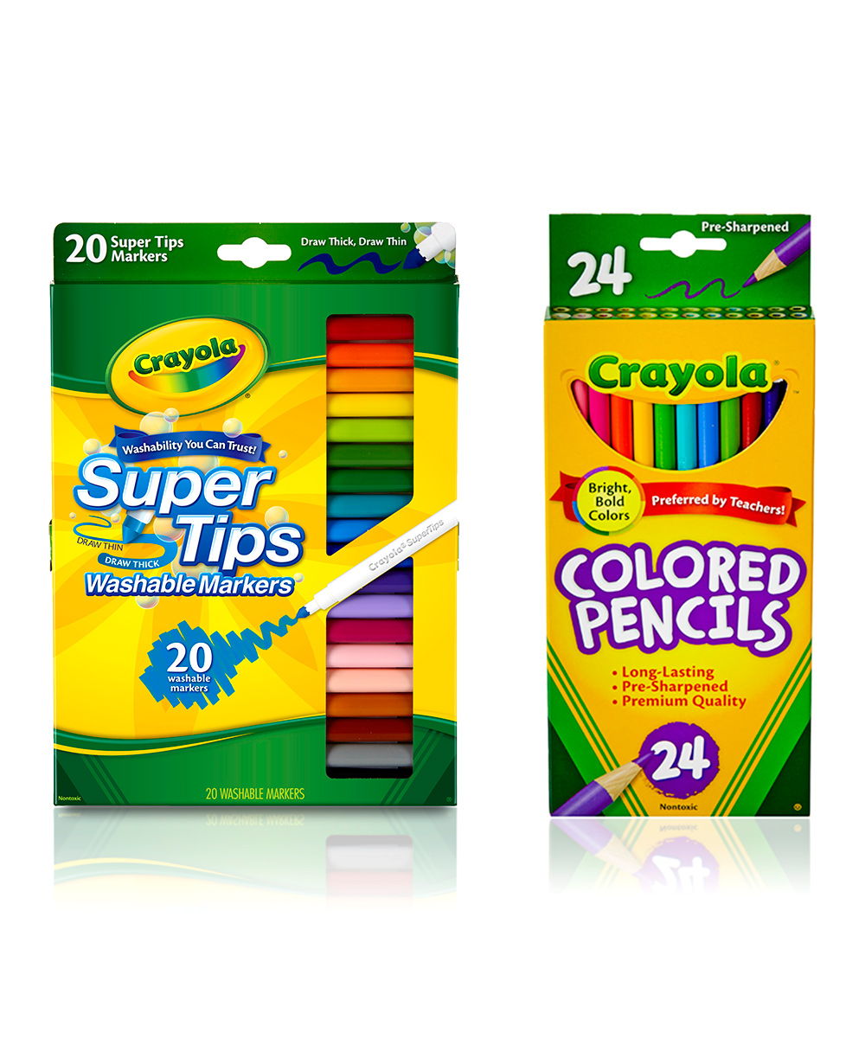
* One (1) Box of 24 ***Crayola*** Crayons
* One (1) Pack of Thin ***Crayola*** Washable Markers
* One (1) Pack of Thick ***Crayola*** Washable Markers
* One (1) Pack of EXPO Dry Erase Markers
* Three (3) **Jumbo** Sized Clear Glue Sticks
* Four (4) Jumbo Box of Tissues
* Four (4) Packs of 3M Post-Its
* Sani-hands/Wet Ones/Wipes
* Bottle of Hand Sanitizer
* 2 Highlighters
* Ziploc Large Gallon Sized- (Boys Purchase) or Quart-Sized Bags-(Girls Purchase)

*Supplies for Specials*

* One (1) Spiral Sketchbook 8.5” x 11” or the largest 9” x 12”

*(for Art, if you currently have a sketchbook with Ms. Meller, you* ***do NOT*** *need to send another one)*

* Two (2) Green Two-Pocket Folder *(for Art & Music)*
* One (1) One Inch Green Binder w/ lined paper *(for Spanish)*
* One (1) Box of 24 Crayola Crayons *(for Spanish)*

Thank you!

The Third Grade Team