Second Grade Supply List
2019-2020

- A light healthy snack for your child every day (he/she brings this with them daily)
- Backpack (no wheels please)
- 2 boxes of 12 #2 pencils (sharpened; Ticonderoga brand only!)
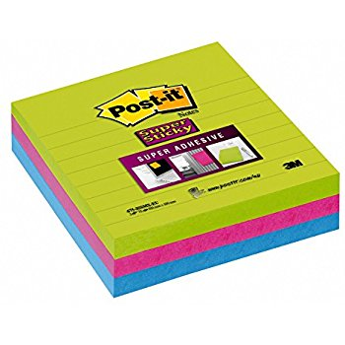
- 1 box of 12 colored pencils (sharpened)
- 1 pack of 12 markers
- 1 box of 24 crayola crayons
- 2 packs of fine tip dry erase expo markers (black only)
- 1 hand sanitizer
- 3 boxes of tissues
- 1 pack of glue sticks
- 3 packs of lined post-it notes
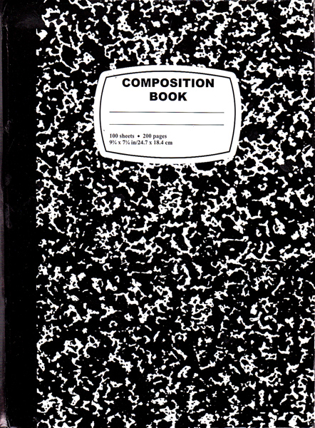
- 1 child-sized scissor
- 1 box of sandwich Ziploc bags
- 1 box of gallon Ziploc bags
- 6 black and white marble journals
- 1 green pocket folder
- 1 blue pocket folder
- 1 red pocket folder
- 1 yellow pocket folder
- 1 orange pocket folder
- 1 purple pocket folder
- 1 Hard Plastic two-pocket folder
- Earbuds

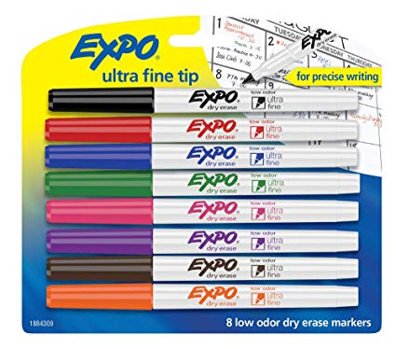
Supplies for Specials
- 1 Spiral Sketchbook 8.5” x 11” or the largest 9” x 12”
(for Art, if you currently have a sketchbook with Ms. Meller, you do NOT need to send another one)
- 1 Yellow two-pocket folder (for Art)
- One, 1 inch blue binder with lined paper (for Spanish)
- One Box of 24 Crayola Crayons (for Spanish)
        - One two-pocket folder (for Music)
Thank You!

