Kindergarten Supply List
2019-2020

Please bring the following supplies to school as soon as possible in order to facilitate instruction.

- A Backpack (No Wheels)
- Lunchbox
- Two (2) Packs of 25 Sharpened #2 Ticonderoga Pencils
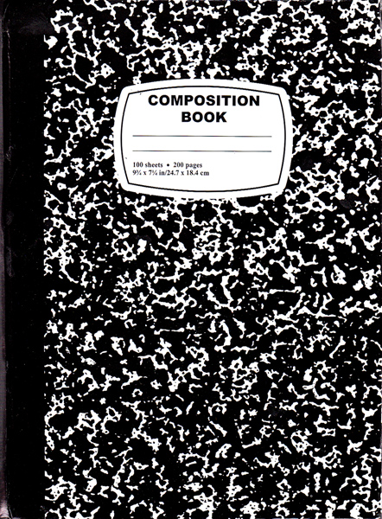
- Three Black and White Marble Composition Notebooks
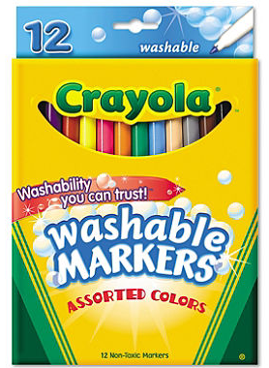
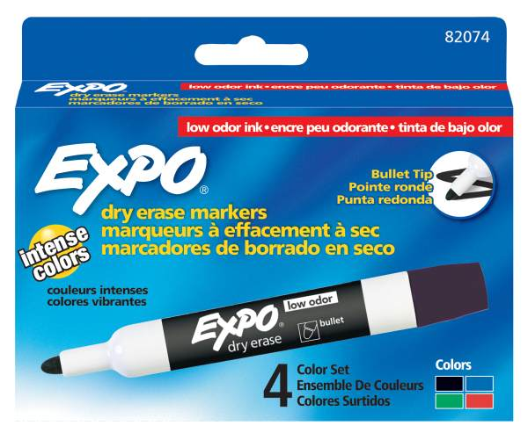
- One (1) Pack of EXPO Low Odor Dry Erase Markers (Preferably black)
- Two (2) Boxes of 24 CRAYOLA CRAYONS
- Two (2) Packs of Wet Ones
- Tissues
- Over the Ear Headphones-Labeled in a Ziploc Bag
- Change of clothes-Labeled in a Ziplock Bag
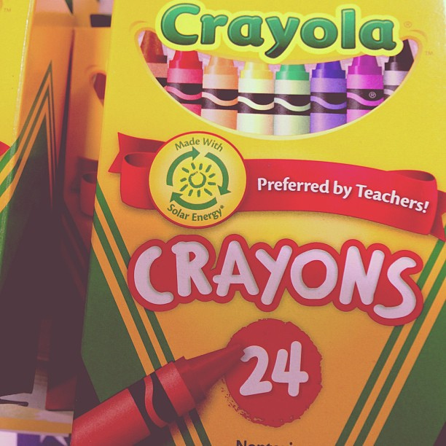
Spanish Class
- 1” White Binder
- One (1) Pack of Crayons
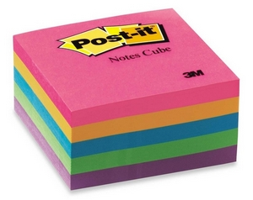
Art Class
- Red 2-Pocket Folder
- One (1) Spiral Sketchbook 9x12- 30 sheets or more (these sketchbooks are sold at the $1 store or art stores such as A.C. Moore)

Thank you!
Ms.Garcia

