Dear Students and Families,

Congratulations and welcome to fourth grade! We have fun and exciting plans for the upcoming school year. Below is a list of materials that you will need to be prepared and organized for the year. This supply list may also be found on the E-board. If you have difficulty finding any of these items, please let your teacher know when school starts.

CLASSROOM SUPPLIES:
- A Backpack (No Wheels)
- Earbuds/headphones (for use with laptops)
- 5 composition notebooks
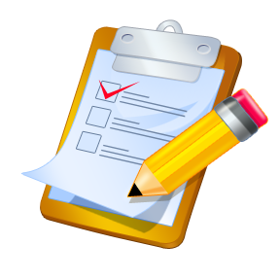
- 4 sturdy pocket folders
- 24 pencils (sharpened)
- 1 pack of dry erase markers (4 pack)
- Thin markers (small pack)
- pouch for pencils, crayons and markers (no hard cases)
- 2 JUMBO book covers
- 2 packs of 3”x 5” index cards
- 2 packs of 5” x 7” index cards
- 1 box of ziploc quart-sized bags
- 3 boxes of tissues
- 1 container of Purel
- 1 container of wipes
ART CLASS SUPPLIES:
- One (1) Spiral Sketchbook 9” x 12”
– 30 sheets or more (These sketchbooks are sold at the $1 store
or art stores such as A.C. Moore)
- One (1) BLUE Two Pocket Folder
SPANISH CLASS SUPPLIES:
- 1" white binder with lined paper
- 1 box of crayons
MUSIC CLASS SUPPLIES:
- 1 small notebook (i.e. composition notebook)
HOME SUPPLIES:
- Colored pencils, crayons, or markers
- Dictionary
- Scissors
- 2 Glue sticks
- Pencils and a sharpener
- A ruler and protractor
- Teaneck Library Card
Enjoy your summer! Remember to read and practice your math facts. We are looking forward to meeting you on the first day of school.
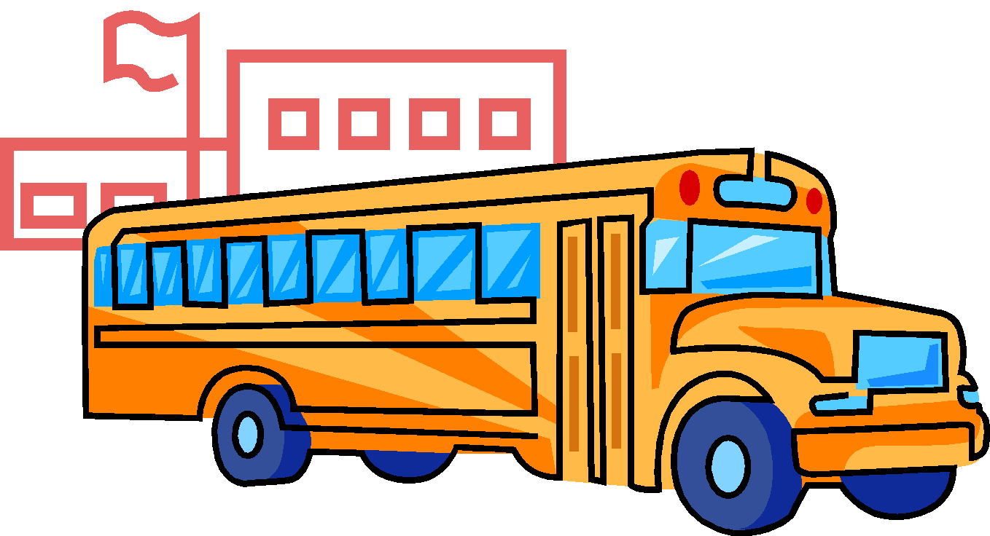
Sincerely,
Fourth Grade Teachers

